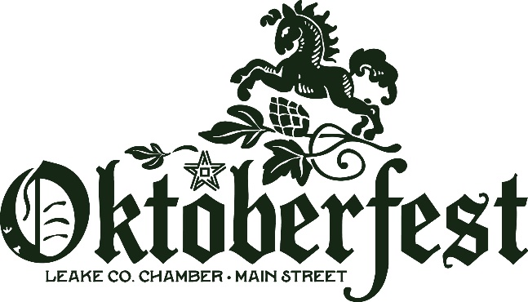
Vendor application 2026
Event Date: October 17th 9:00am-3:00pm
Location: McMillan Park 515 MS Hwy16 E, Carthage, MS 39051
Event Setup Times: Fri. Oct. 16 1-6:00pm & Sat. Oct. 17 6:00am-9:00pm
Please complete the form and email to director@leakems.com or mail to
MSCLC P.O. Box 1337 Carthage, MS 39051

Company Name: ______________________________________________________________

Contact Person: ______________________________________________________________

Email: _____________________________ Phone:____________________________

Website/Social Media:______________________ Tax ID # or SS # _____________________

Mailing Address: ____________________________________________________________________

Summary/specific list of items to be sold: ______________________________________________________________________________________________________________________________________________________________________________________________________________________________________________________________________________
All booths will be 10x10 spaces. Maximum amount available is 2 booths per vendor. Electricity is not guaranteed; please bring generators/personal power outlets as a backup option. Please make all checks payable to Main Street Chamber of Leake County (MSCLC).
Please Check Vendor Option:
Non-Profit……$10 fee _____ Food Truck………$100 ____
Retail…………$50 fee _____ MSCLC MEMBER…..YES_____ NO_____
Food………….$80 fee _____ Number of Booths Requested: _________
General Guidelines

DEADLINES
October 10th – Full Balance is Due- No exceptions. Failure to remit full booth payment by this deadline forfeits your participation in the show. All non-payments will then allow the waitlist to be added.
CANCELLATION/REFUNDS
If you wish to cancel your reservation, please contact the Chamber office and provide a valid reason for the request. It may take up to 2 weeks for a refund to be processed. All refunds are subject to approval by the Board of Directors. The deadline to request a refund is October 20th.
BOOTH INFORMATION
All booths will be 10’x10’ and located throughout McMillan Park. Each space will be numbered and you will receive a detailed vendor packet with map and booth placement by October 15th. Sharing of booths between stores/vendors is absolutely not allowed. If you try to extend past your space you will be charged an additional fee that must be paid that day. You must bring your own tables, chairs, displays, and all of your items must fit within your allotted space. Please note that we DO NOT provide any tables or chairs. Electricity is not guaranteed-please bring your own generators or power sources if needed.
REGISTRATION PROCEDURE
Please return the enclosed application as soon as possible. We operate on a first-come, first-served basis, allocating booth space in the order in which accepted applications are received. You will not be placed on the vendor list until we have received both your application and payment in October. We have a strict registration deadline for October 10th due to event planning and logistics. A vendor confirmation packet will be mailed prior to the event. Booth placement is not guaranteed until your receive your confirmation packet. This event is an outdoor event and will be held rain or shine unless extreme weather conditions arise, such as tornadoes, hurricanes, or flash flooding.
Products/Merchandise
Oktoberfest does not accept resale, AI generated artwork, direct sales or MLM company vendors. Handmade products, clothing, accessories, crafts, artwork, beauty products, etc. will be deemed retail vendor status. Baked goods, prepared foods, prepared beverages, snacks, concessions, etc. will be deemed food vendor status. Any food prepared in a food truck/trailer that is considered mobile will be required to pay the food truck fee.

SALES TAX
Sales Tax is collected on-site at the Oktoberfest. ALL Vendors will report sales tax in accordance with the rules and regulations of Oktoberfest and State of Mississippi Department of Revenue. Oktoberfest has an event permit that requires all participating vendors, regardless of business status, to collect sales tax produced at the event. You will remit a check or cash for the amount of sales tax at the end of the festival the day of. Non-profit organizations that are tax-exempt must provide proof of tax exemption status from the Internal Revenue Service. VENDORS WHO FAIL TO REMIT SALES TAX IMMEDIATELY AFTER OKTOBERFEST CLOSING WILL NOT BE INVITED BACK TO FUTURE EVENTS.
LOST OR STOLEN PROPERTY
Merchants and customers, not the Oktoberfest or its entities, are responsible for the safe keeping of personal property and goods offered for sale. In the event of stolen or lost property, the police will be contacted and appropriate action taken.
OVERSIGHT
On behalf of the Main Street Chamber of Leake County, the Main Street Director, serving as the Oktoberfest director, shall enforce the guidelines uniformly, consistently, fairly, and without bias or favor. The director shall have the authority to interpret, enforce, and amend the guidelines. Furthermore, the director has the right to accept or decline any items or vendors, new or returning.
CONTRACT AGREEMENT
If you have any questions, please contact our office at 601-267-9231 or email Dakota Presley, MSCLC Executive Director, at director@leakems.com. This document serves as your application. If you are accepted as a vendor, your payment will be invoiced and due in the month of October, and this document becomes your binding contract. We look forward to your participation!
Company Name ______________________________________________
Signature ____________________________________________________
Date ________________________________________________________
(Internal Office Use Only)
Accepted by MSCLC____________________________________________
Date ________________________________________________________

